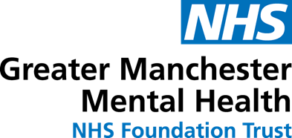

The Bolton Mental Health Support Team (MHST)
Our school is part of a cluster of schools and colleges in Bolton who are supported by the MHST. The MHST work with our designated Mental Health Lead to provide 3 functions:
- deliver evidence-based interventions for mild-to-moderate mental health difficulties
- support the senior mental health lead in each school or college to introduce or develop their whole school or college approach to mental health
- give timely advice to school and college staff, and liaise with external specialist services to help children and young people to get the right support and stay in education
To find out more about how the MHST might be able to support your child, please speak with your school’s designated mental health lead.

