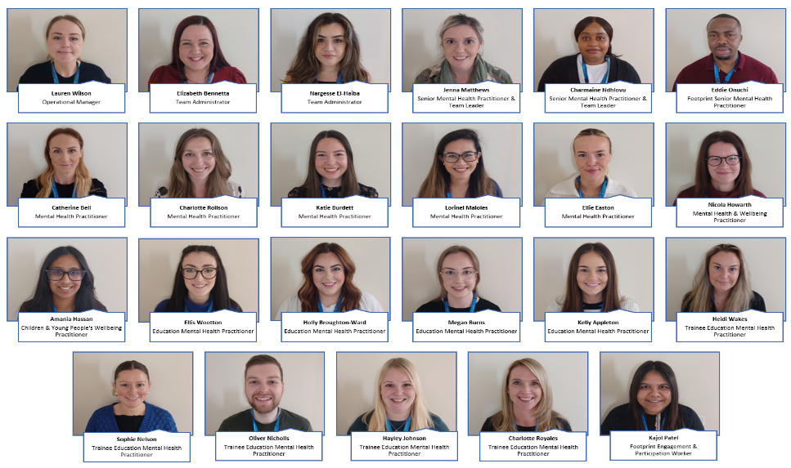


Who are Bolton Mental Health Support Team (MHST)?

We are a team who works for the NHS and are working in schools and colleges across Bolton to help children and young people with mental health difficulties.

How can we help?

We are trained to work with children and young people who may start to experience symptoms of:
Anxiety
Worry
Low mood

We are trained to provide:
- Support and advice
- Mental Health assessments
- Cognitive Behavioural Therapy (CBT) informed interventions
- Workshops and training for children, parents, and teachers
- Whole School Approach

What is a Mental Health Practitioner and an Education Mental Health Practitioner (EMHP)?

Mental Health Practitioners, EMHP’s and Trainee EMHP’s work across education and healthcare to provide evidenced based, low level mental health support for children and young people in primary schools, high schools and also colleges.
Trainee’s also spend two days a week at university.
Bolton MHST’s allocated time in your school is:


We can also continue to support children and young people during school holidays.

Our goals are:

- To deliver 1:1 and group interventions to children, young people, and parents.

- To work with teachers to develop whole school/college approaches to improve everyone’s mental health.

- To give advice to school/college staff to help children get the right support.

We are all very excited to work with your school and we look forward to meeting you all soon!

