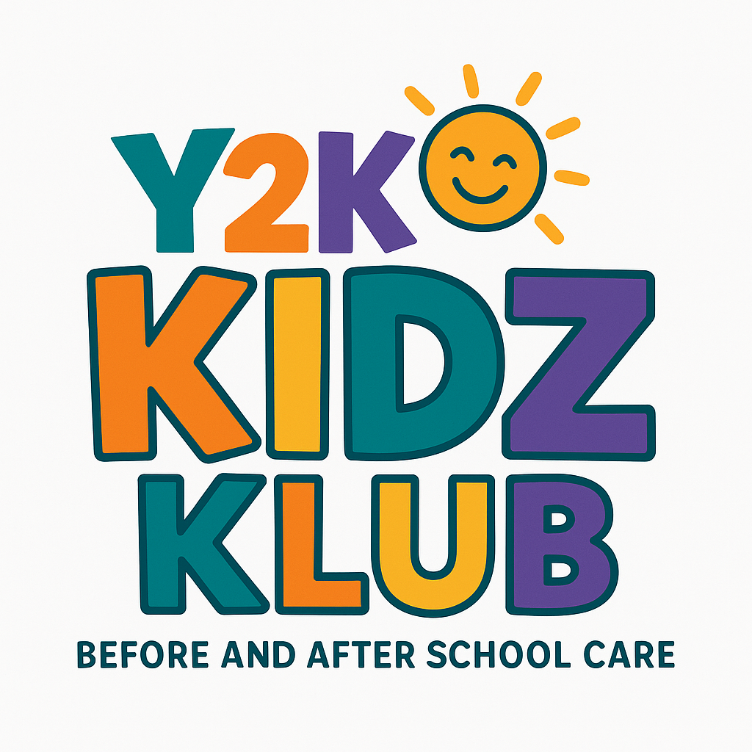

Subject: Exciting News: Y2K Kidz Klub Welcomes New Ownership 🎉
Dear Parents & Families,
We’re excited to share that Y2K Kidz Klub is beginning a new chapter under our ownership as Y2K Kidz Klub UK Ltd.
After 25 incredible years, Cath Dunning has retired. We’d like to thank her sincerely for everything she has built and achieved. She has created a wonderful environment for children, and we wish her the very best in her retirement.
From wc 5th January 2026 Y2K Kidz Klub will be under new ownership, and will operate as Y2K Kidz Klub UK Ltd. We are excited to introduce you to the new owners:

⭐ Tim & Sue Rees
Many of you will already know Tim Rees, who runs Rees Sports, widely recognised across Bolton as a trusted PE provider in schools and a leader of popular after-school sports clubs. Tim and his team have been working in primary schools across the area for the last 15 years, delivering high-quality, energetic and engaging activities. Rees Sports currently teach PE at Kearsley St Stephen’s, St Matthew’s, and St Teresa’s Primary Schools.
Going forward, the existing Y2K staff will continue to run the Kids Klub, ensuring consistency, familiarity and the same caring environment your children know and love.
Alongside them, Rees Sports staff will support and enhance the delivery, bringing even more fun games, sports and active play to the sessions.

📲 Booking System (Kids Club HQ)
To help with consistency, Y2K Kidz Klub UK will continue using the Kids Club HQ booking platform. However, as part of the transition, bookings will now be managed through a new link:
👉 New Booking Link:
https://y2kkidzklubuk.kidsclubhq.co.uk/rdr?u=home
Parents will need to set up a new profile when booking. The process is quick and simple, and once registered you’ll be able to manage your child’s bookings easily.

🌟 A Fresh Chapter – Come and Join Us!
We’re excited to build on Cath’s success and would love for you to continue with us—or give us a try if you’re new!
If you have any questions, please do not hesitate to contact us.
Warm regards,
Tim & Sue Rees
New Owners – Y2K Kidz Klub UK Ltd
📱 Mobile: 07971 316239
📧 Email: tim@reessports.co.uk

